**Normalisation**

**Task 1**

1. Initial dependency diagram

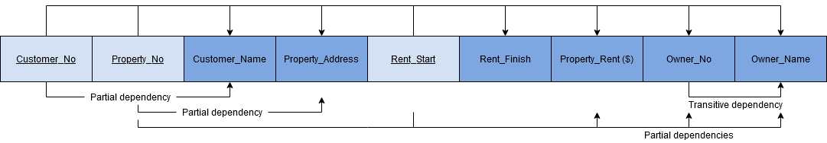

1. The relation is currently in first normal form (1NF). There are no repeating groups in the table and there is a proper (composite) primary key such that all other attributes depend on that primary key. However, the relation is not in second normal form (2NF) because there are partial and transitive dependencies between the attributes.
2. Third normal form (3NF) dependency diagrams

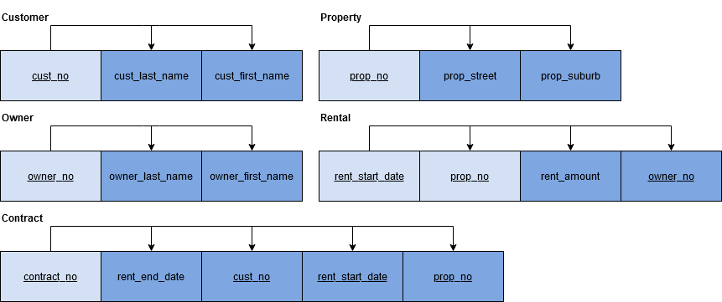

1. Entity relationship diagram

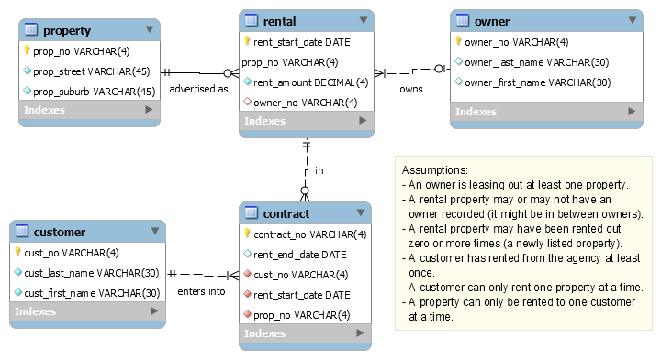

**Task 2**

1. Initial dependency diagram

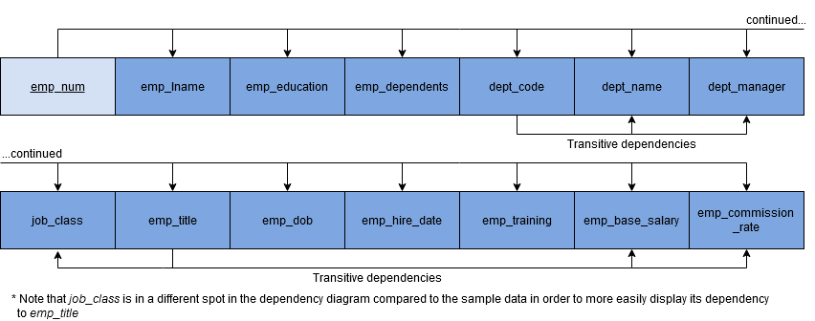

1. Revised third normal form (3NF) dependency diagrams

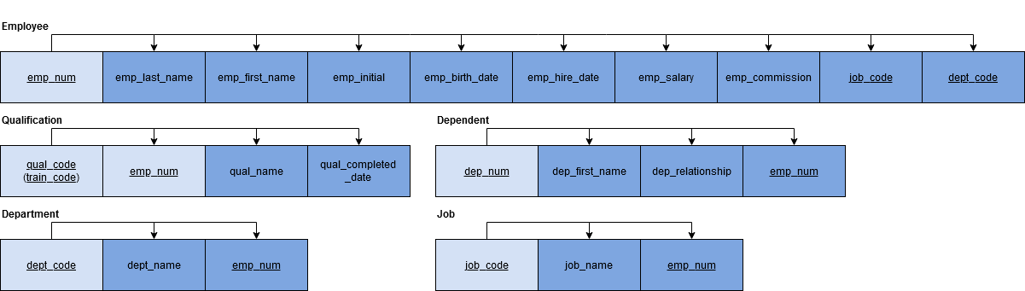

1. Entity relationship diagram

